
RAMAIAH
INSTITUTE OF TECHNOLOGY
USN | 1 | M | S

(Autonomous Institute, Affiliated to VTU)
(Approved by AICTE, New Delhi & Govt. of Karnataka) Accredited by NBA & NAAC with ‘A’ Grade

SUPPLEMENTARY SEMESTER EXAMINATIONS – JULY/AUGUST 2018

Course & Branch | : | B.E. : Electrical and Electronics Engineering | Semester | : | VII
Subject | : | Power Systems - II | Max. Marks | : | 100
Subject Code | : | EE702 | Duration | : | 3 Hrs

Instructions to the Candidates:
- Answer one full question from each unit

 |  | UNIT- I
1. | a) | Explain the following with examples: (i) Tree (ii) Co-tree (iii) Oriented graph iv) Primitive Network v) primitive element. | CO1 | (10)
 | b) | Model the 𝜋-equivalent circuit of transformers with off-nominal turns ratio used in formation of bus admittance matrix. | CO1 | (06)
 | c) | List the properties of Element node incident matrix. | CO1 | (04)
2. | a) | Derive the step-by-step algorithm for formation of bus impedance matrix, when an element is added to the partial network is branch. | CO1 | (10)
 | b) | 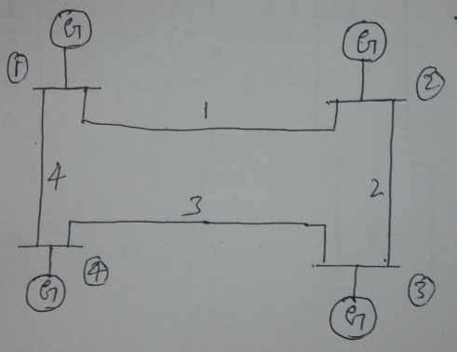  Fig.2(b)  For the power system shown in the Fig. 2(b), select ground as reference and a tree for which the link elements are between the buses 1-2,1-4,4-3 and 2-3. Write basic cut-sets and basic loop incidence matrix. Verify the relation C_{B}=-B_{L} ^{T}. | CO1 | (10)
 |  | UNIT- II
3. | a) | Discuss in brief the advantages of using bus admittance matrix in load flow analysis. | CO2 | (04)
 | b) | Derive the expression in polar form for the typical diagonal elements of the sub matrices of the Jacobian in Newton Raphson method of load flow analysis. | CO2 | (10)
 | c) | Compare gauss Seidel and Newton Raphson methods of load flow analysis. | CO2 | (06)
4. | a) | Obtain the load flow solution at the end of the first iteration of the power system shown in Fig Q.4(a). The data is given in Table below. The solution is to be obtained for the following cases:  i. All buses except bus 1 are PQ buses with acceleration factor of 1.6.  ii. Bus 2 is a PV bus whose voltage magnitude is specified as 1.04.  iii. Case(ii) if 0.25≤Q₂≤1.0 pu.  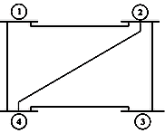  Fig Q.4(a) | CO2 | (08)
  Line Data
  SB | EB | R(pu) |  |  | X(pu)
  1 | 2 | 0.05 |  |  | 0.15
  1 | 3 | 0.10 |  |  | 0.30
  2 | 3 | 0.15 |  |  | 0.45
  2 | 4 | 0.10 |  |  | 0.30
  3 | 4 | 0.05 |  |  | 0.15
  Bus Data
  Bus No | P_{i}(pu) |  | Q_{i}(pu) | V_{i}
  1 | -- |  | -- | 1.04  $∠$0⁰
  2 | 0.5 |  | -0.2 | --
  3 | -1.0 |  | 0.5 | --
  4 | -0.3 |  | -0.1 | --
 | b) | Explain how buses are classified to carryout load flow analysis in power systems. What is the significance of slack bus? | CO2 | (06)
 | c) | Explain the fast decoupled load flow analysis. | CO2 | (06)
 |  | UNIT- III
5. | a) | Derive equal incremental cost criterion for economic generation scheduling neglecting transmission losses. Also write the step by step algorithm for obtaining economic loading of generators. | CO3 | (10)
 | b) | Fig. 5(b) shows a system having two plants 1 and 2 connected to buses 1 and 2 respectively. There are two loads and a network of four branches. The reference bus with voltage of 1.0<0⁰pu shown on the diagram. The branch currents and impedances are as given. Calculate the loss formula coefficients of the system in pu and in reciprocal megawatts, if the base is 100 MVA.  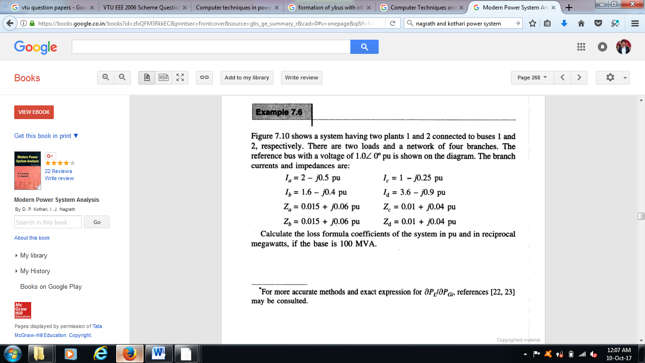  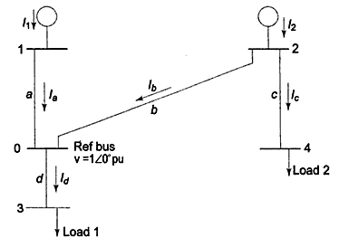  Fig. 5(b) | CO3 | (10)
6. | a) | What are transmission line loss coefficients? Derive an expression for transmission line losses as a function of plant generation for a two plant system. | CO3 | (10)
 | b) | The fuel inputs per hour of plants 1 and 2 are given as:  F₁= 0.2 P²₁+40P₁+120 Rs/hr  F₂= 0.25 P²₂+30P₂+150 Rs/hr  Determine the economic operating schedule and the corresponding cost of generation, if the maximum and minimum loading on each unit is 100MW and 25MW. The demand is 180MW and transmission losses are neglected. If the load is equally shared by both the units, determine the saving obtained by loading the units as per equal incremental production cost. | CO3 | (10)
 |  | UNIT- IV
7. | a) | Discuss the methods to improve the transient stability of a given power system. | CO4 | (06)
 | b) | 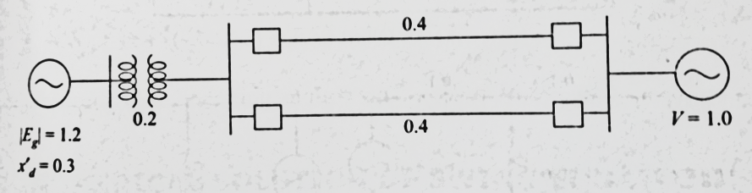  Fig. 7(b)  A 50Hz synchronous generator having inertia constant H=5.2MJ/MVA and Xd=0.3pu is connected to an infinite bus through a double circuit line is shown in Fig.7(b). The reactance of the connecting HT transformer is 0.2pu and reactance of each line is 0.4pu. Eg=1.2pu and V=1.0 and Pe=0.8pu. A three phase fault occurs at the middle of one of the transmission line and is cleared without line outage at 2.5 cycles. Plot the swing curve. Use point by point method. | CO4 | (14)
8. | a) | Discuss the method of transient stability of a given power system based on Modified Euler’s method. | CO4 | (10)
 | b) | Discuss the method of transient stability of a given power system based on Runge – Kutta method. | CO4 | (10)
 |  | UNIT- V
9. | a) | A 100 MVA synchronous generator operates on full load at frequency of 50 Hz. The load is suddenly reduced to 50 MW. Due to time lag in governor system, the steam valve beings to close after 0.4 seconds. Determine the change in frequency that occurs in this time. H=5kW-sec/kVA of generator capacity. | CO5 | (05)
 | b) | Develop a mathematical model for generator-load model and draw the corresponding block diagram. | CO5 | (10)
 | c) | Discuss the need for load-frequency control in power system. | CO5 | (05)
10. | a) | Draw the conventional Governor model and discuss the functions of major parts of it and explain its characteristics. | CO5 | (10)
 | b) | What is the need for compensators in power system? Explain any one type of Static VAR compensator. | CO5 | (10)

****************

